Rigid Box Estimate Sample

The following screen shots show an example of a Rigid Box Estimate.
The first step is to define the parent item, know as the billable item.
Please note, the item may be assembled and shipped as a unit.
Likewise, the item may be unassembled and shipped separately.

ESTIMATE FOLDER – SET BUTTON

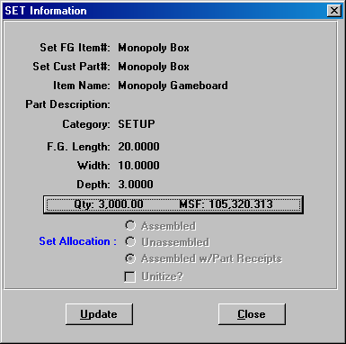

ESTIMATE FOLDER

The Estimate folder shows each item that is part of the set including purchased items.
In this estimate, there are four components to the Monopoly Game.
Each item may be for unique paper board and unique wrap material, however item such as the top and bottom may be cut out of the same sheet.

Please note, each component requires only a few fields including the customer code, style, width, length, depth, material type and the system generates all the folding folders. Hence, estimates and quotes can be creates in minutes.

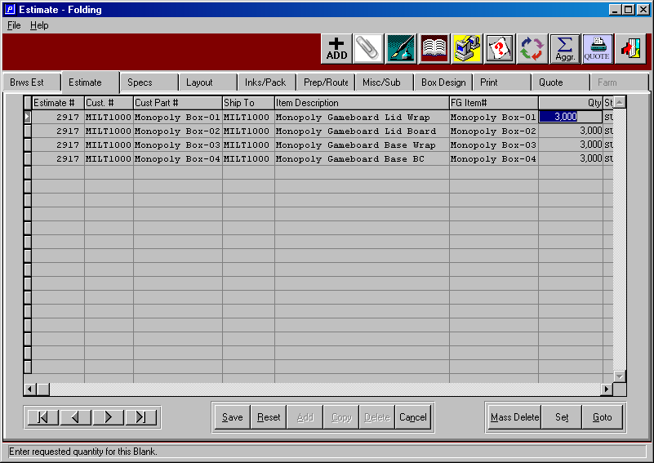
GOTO BUTTON

The go to button on the estimate folder allows changing the layout of each component.
Each component may be run on separate sheets or similar items may be run together.
In this example, the paper wrap material is manufactured on separate rolls with separate machine operations, whereas the bending chip board material is run together. Please note, each item may have multiple up on each sheet and there may be drop off sheets.

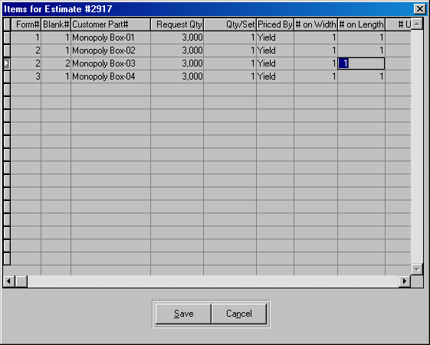
SPEC FOLDER

The Spec Folder houses the specific details of each component including box size, blank width, blank length, board, die number, cad number, salesman commission and adhesive material. Each dimension is used to determine the machine routing and each machines setup time, run speed and waste standards. This example is for a gold wrap material.

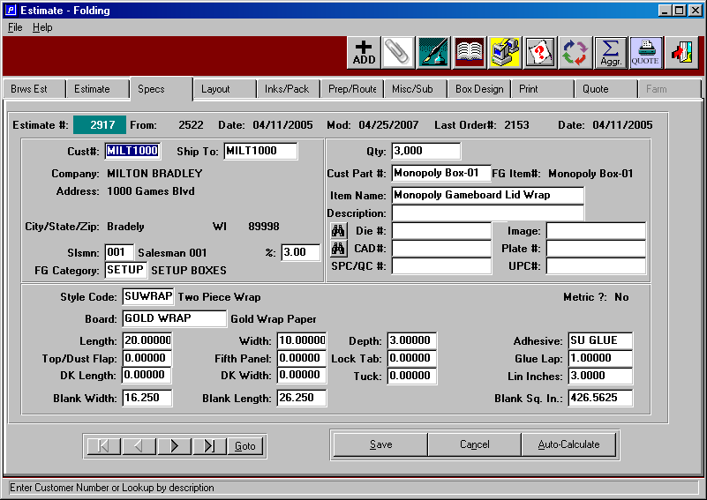

SPEC FOLDER

This example is for a paper board for the lid. Note, this is part ending with 02. The paper wrap material will be glued to the lid board to become one sub-assembly. Likewise, the bottom and bottom wrap will become another sub-assembly.

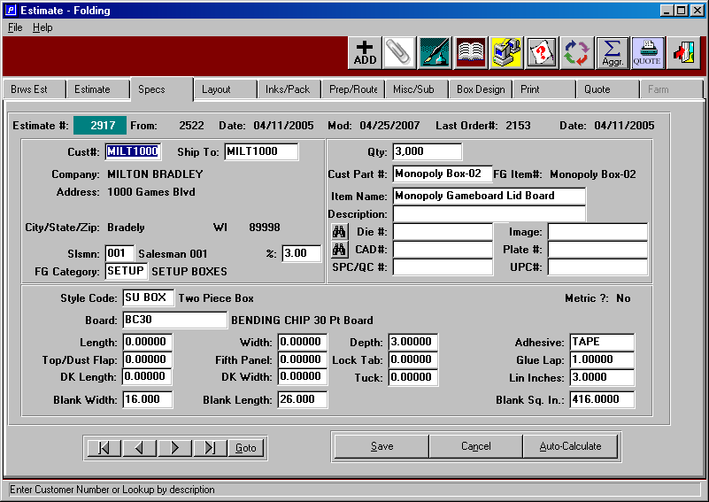
LAYOUT FOLDER

The layout folder houses the specific details of each component which may be slit, scored, printed and die cut. The gross sheet allows cutting the wrap roll into sheets, which may be cut on the miter saw, slitter and die cutter. The gross sheet size is used to determine the machine routing for the slitting or guillotine cutting. The Machine feed may be used for a guillotine as well as a printing press. Finally, the die size indicates how many up may be cut on the die cutter. All dimensions are used and each machines setup time, run speed and waste standards. This example is for a gold wrap material.

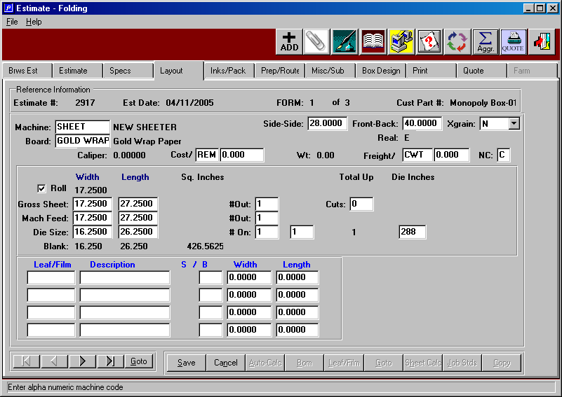
LAYOUT FOLDER

The machine entered is used to automatically calculate the number up and number out of a sheet or a roll. This may be changed to any layout required simply by changing the number up and the sheet size is recalculated. In this example, the bending chip material will be used for both the bottom material and the lid or top material, hence the sheet width is twice the blank width plus machine trim allowance. Alternatively, the paper board material may be cut from different sheets or even different material. For example, a plastic cover lid and a board bottom would require separate sheets, which are known as forms. All dimensions are used and each machines setup time, run speed and waste standards. This example is for the lid and bottom to be cut from bending chip.

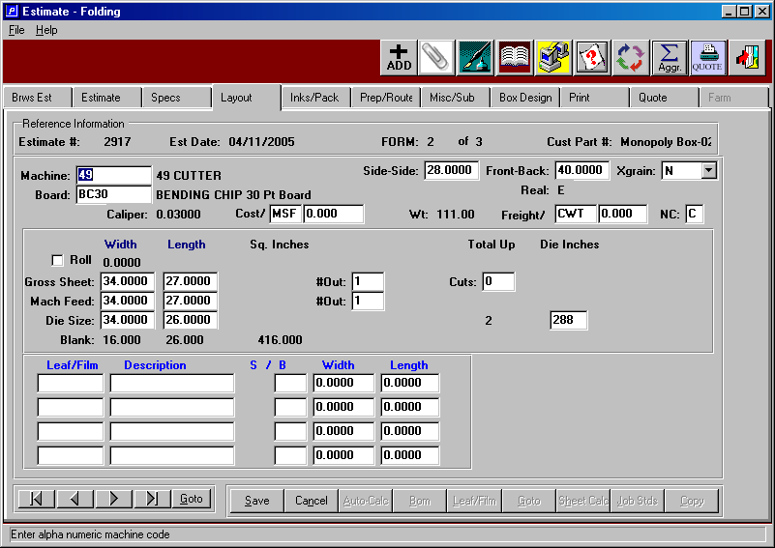
INK & PACKING FOLDER

The inks and packaging folder houses printing inks that may be printed on any part of the rigid box. The directions to the game may be printed on the inside of the lid or special graphics may be added to the paper wrap.

Assembled sets will have just one packing code which may be a bin, corrugated case or pallet. Alternatively, each component may be shipped separately.

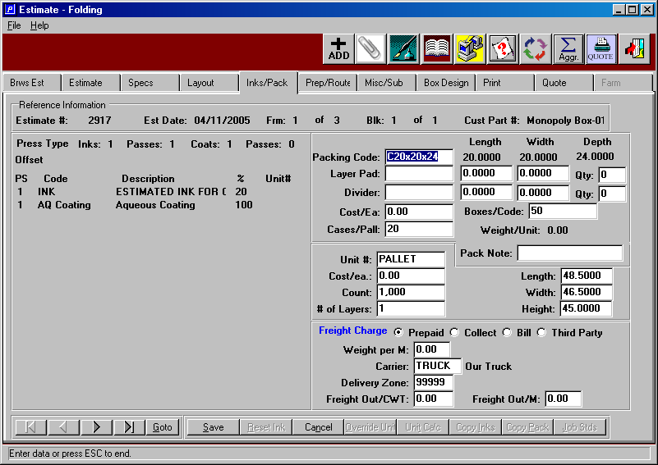

MISC / SUBCONTRACT COSTS FOLDER

The miscellaneous and sub contractor folder houses any outside labor or material that is purchased to produce the final assembled setup box product.

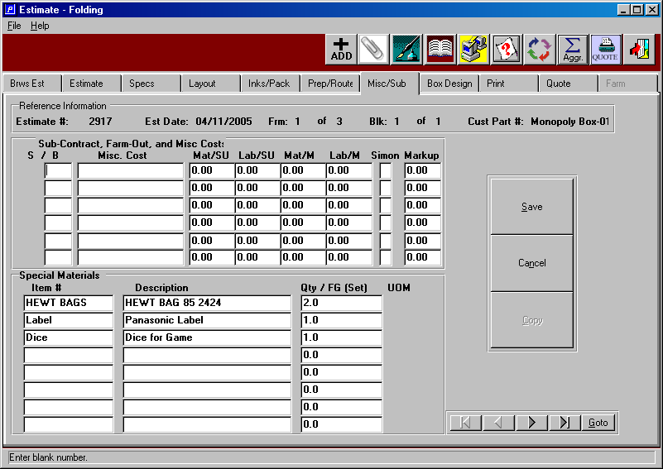

PREP / ROUTING FOLDER

The preparation and machine routing folding displays both the plate and die charges as well as the machine routing for each form. The cost and markup are added to any plate or die charge, which may be included in the cost per thousand or may be billed separately or included at no cost.

The machine routing is automatically generated for each sheet including the make ready time, setup waste, production run speed and run waste spoilage. The estimator may override all details of the machine standards including the crew size.

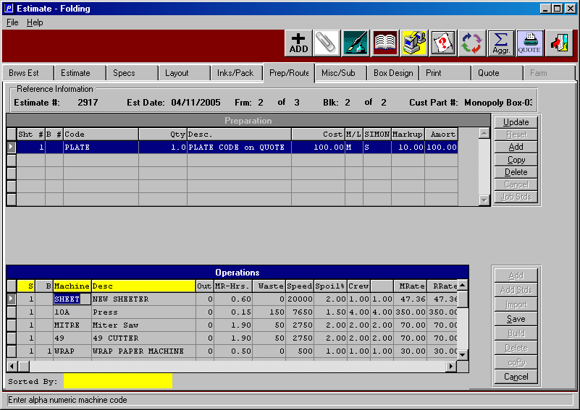

BOX DESIGN FOLDER

The box design folder shows the 2D and 3D image of the final product. Alternatively, the die image and cad image may also be displayed. This is also available on the plant floor to provide a paperless job ticket including any last minute graphic changes.

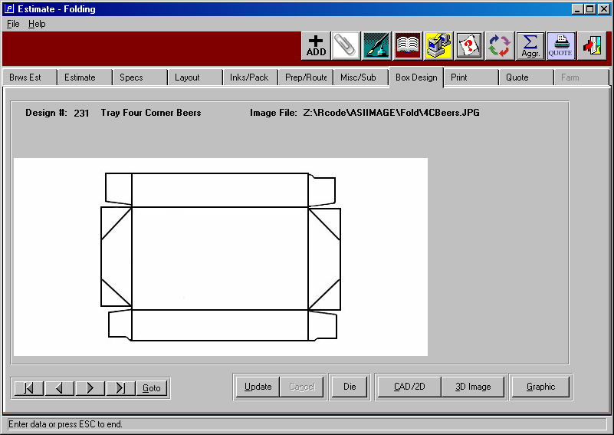

BOX DESIGN FOLDER

The box design folder shows the 2D and 3D image of the final product.

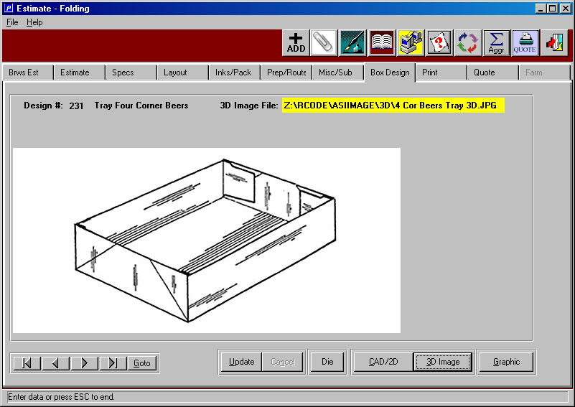

PRINT FOLDER

The print folder calculates cost of each estimate quantity requested showing the out of pocket total factory cost, the full cost which includes GS &A, freight, commissions and other markups and finally, the sell price and profit. The what if button allows changing the gross profit, net profit or selling price to achieve the desired markup.

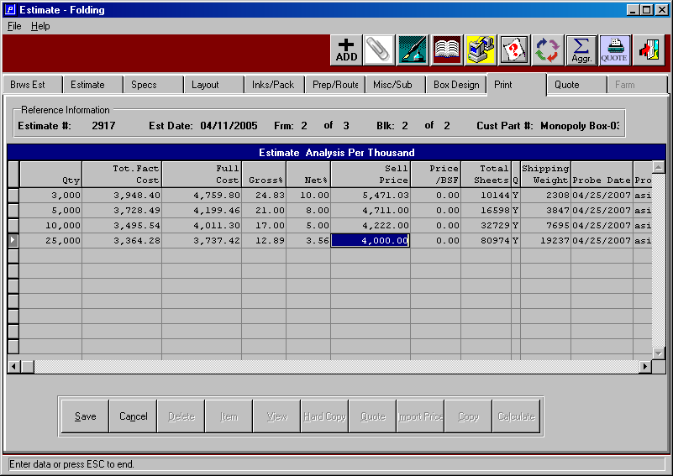

PRINT FOLDER – QUOTE BUTTON

Once the estimate is calculated via the calculate button, the quote button generates a quote with one keystroke. The quote history file stores are cost and sell price data for each quantity estimated. When adding an order, this data transfers directly to the order.

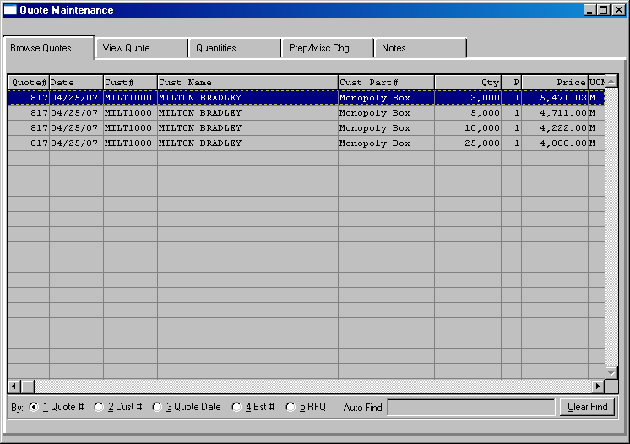

QUOTE FORM

The quote form provides the printing of the form by pressing the PRINTER ICON.
The quote file also allows adding notes to the quote. Another option on the quote file is to create a price list sheet for any customer.

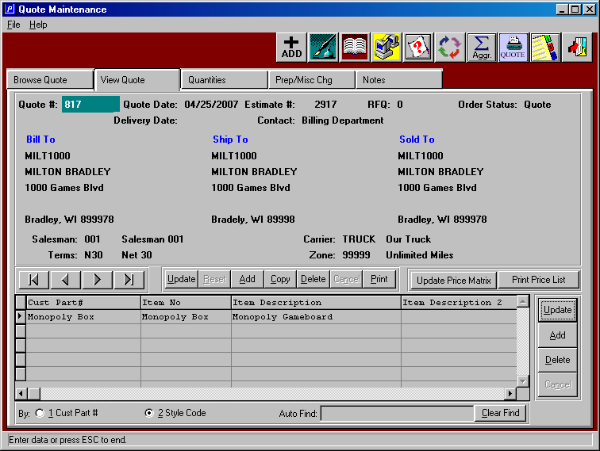

QUOTE FORM

Many plain paper form as well as pre printed forms are available at no cost. Enclosed is a sample of one example. The form may be emailed, printed, faxed, downloaded to a file or viewed to the screen.

